Capacity
# Source: AI Source: Provided by: [Data Path: Persons Table -> ID Column: 1, Name_En Column: Motasem Essam] -> From: [ChatGPT] on [7/17/2026]
Capacity is the measurement of the maximum amount of a substance, usually a liquid or gas, that a container can hold. It describes the storage ability of a container rather than the space occupied by the container itself.
Capacity is widely used in everyday life, science, engineering, medicine, chemistry, food preparation, manufacturing, and commerce.

Definition
# Source: AI Source: Provided by: [Data Path: Persons Table -> ID Column: 1, Name_En Column: Motasem Essam] -> From: [ChatGPT] on [7/17/2026]
Capacity is the physical quantity that measures the maximum volume of a substance that a container can hold.
Capacity is most commonly expressed using liters (L) and milliliters (mL).

Purpose
# Source: AI Source: Provided by: [Data Path: Persons Table -> ID Column: 1, Name_En Column: Motasem Essam] -> From: [ChatGPT] on [7/17/2026]
Capacity measurement is used to:
- Determine how much liquid or gas a container can hold.
- Measure beverages and food ingredients.
- Dispense medicines.
- Design storage tanks.
- Package products.
- Perform laboratory experiments.
- Calculate storage requirements.

SI Unit
# Source: AI Source: Provided by: [Data Path: Persons Table -> ID Column: 1, Name_En Column: Motasem Essam] -> From: [ChatGPT] on [7/17/2026]
Capacity is not an SI base or derived quantity, but it is commonly expressed using the liter (L), which is accepted for use with the SI.
The SI-derived unit corresponding to capacity is the cubic meter (m³).
Relationship:
$$1\text{ L}=0.001 {\text{m}}^{3}$$

Common Units of Capacity
# Source: AI Source: Provided by: [Data Path: Persons Table -> ID Column: 1, Name_En Column: Motasem Essam] -> From: [ChatGPT] on [7/17/2026]
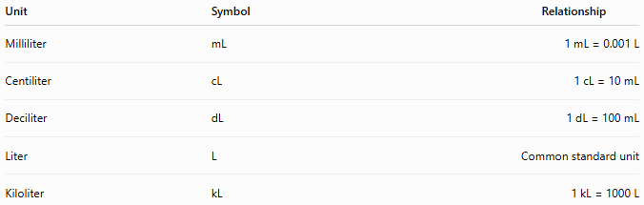
Unit | Symbol | Relationship
Milliliter | mL | 1 mL = 0.001 L
Centiliter | cL | 1 cL = 10 mL
Deciliter | dL | 1 dL = 100 mL
Liter | L | Common standard unit
Kiloliter | kL | 1 kL = 1000 L

Relationship Between Capacity and Volume
# Source: AI Source: Provided by: [Data Path: Persons Table -> ID Column: 1, Name_En Column: Motasem Essam] -> From: [ChatGPT] on [7/17/2026]
Capacity and volume are closely related.
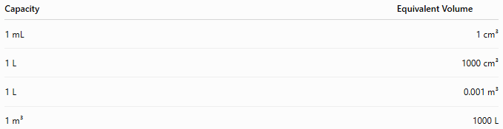
Capacity | Equivalent Volume
1 mL | 1 cm³
1 L | 1000 cm³
1 L | 0.001 m³
1 m³ | 1000 L

Measuring Instruments
# Source: AI Source: Provided by: [Data Path: Persons Table -> ID Column: 1, Name_En Column: Motasem Essam] -> From: [ChatGPT] on [7/17/2026]
Capacity is commonly measured using:
- Measuring cup
- Graduated cylinder
- Beaker
- Pipette
- Burette
- Volumetric flask
- Measuring jug

Measurement Process
To measure capacity:
- Select an appropriate measuring container.
- Fill the container to the desired level.
- Read the liquid level at eye level (bottom of the meniscus for most liquids).
- Record the measurement with the correct unit.

Examples
# Source: AI Source: Provided by: [Data Path: Persons Table -> ID Column: 1, Name_En Column: Motasem Essam] -> From: [ChatGPT] on [7/17/2026]
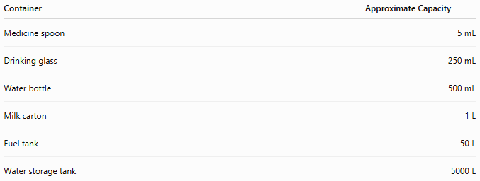
Container | Approximate Capacity
Medicine spoon | 5 mL
Drinking glass | 250 mL
Water bottle | 500 mL
Milk carton | 1 L
Fuel tank | 50 L
Water storage tank | 5000 L

Unit Conversions
# Source: AI Source: Provided by: [Data Path: Persons Table -> ID Column: 1, Name_En Column: Motasem Essam] -> From: [ChatGPT] on [7/17/2026]
Common conversions:
- 1 L = 1000 mL
- 1 mL = 1 cm³
- 1 kL = 1000 L
- 1000 L = 1 m³
Examples:
- 2 L = 2000 mL
- 750 mL = 0.75 L
- 3 kL = 3000 L

Accuracy
# Source: AI Source: Provided by: [Data Path: Persons Table -> ID Column: 1, Name_En Column: Motasem Essam] -> From: [ChatGPT] on [7/17/2026]
Accurate capacity measurement depends on:
- Using calibrated measuring containers.
- Reading the liquid level correctly.
- Keeping the container on a level surface.
- Avoiding parallax error.

Applications
# Source: AI Source: Provided by: [Data Path: Persons Table -> ID Column: 1, Name_En Column: Motasem Essam] -> From: [ChatGPT] on [7/17/2026]
Capacity measurement is essential in:
- Cooking
- Chemistry
- Medicine
- Pharmacy
- Food manufacturing
- Beverage production
- Agriculture
- Fuel storage
- Water treatment
- Laboratory work

Everyday Importance
# Source: AI Source: Provided by: [Data Path: Persons Table -> ID Column: 1, Name_En Column: Motasem Essam] -> From: [ChatGPT] on [7/17/2026]
Capacity measurement is used daily for:
- Measuring cooking ingredients.
- Filling fuel tanks.
- Dispensing medicine.
- Buying beverages.
- Water storage.
- Household cleaning products.
- Laboratory experiments.

Common Mistakes
# Source: AI Source: Provided by: [Data Path: Persons Table -> ID Column: 1, Name_En Column: Motasem Essam] -> From: [ChatGPT] on [7/17/2026]
- Confusing capacity with volume.
- Reading the liquid level incorrectly.
- Using the wrong unit.
- Ignoring the meniscus when measuring liquids.
- Overfilling or underfilling the container.

Key Points
# Source: AI Source: Provided by: [Data Path: Persons Table -> ID Column: 1, Name_En Column: Motasem Essam] -> From: [ChatGPT] on [7/17/2026]
- Capacity measures the maximum amount a container can hold.
- The liter (L) is the most common unit of capacity.
- The SI-derived equivalent is the cubic meter (m³).
- 1 L = 1000 mL = 1000 cm³ = 0.001 m³.
- Capacity is measured using graduated containers such as measuring cups and graduated cylinders.

Capacity vs. Volume
# Source: AI Source: Provided by: [Data Path: Persons Table -> ID Column: 1, Name_En Column: Motasem Essam] -> From: [ChatGPT] on [7/17/2026]
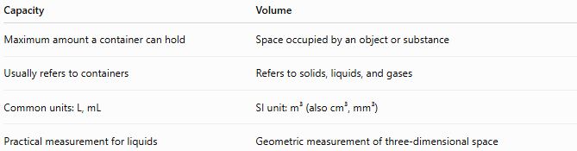
Capacity | Volume
Maximum amount a container can hold | Space occupied by an object or substance
Usually refers to containers | Refers to solids, liquids, and gases
Common units: L, mL | SI unit: m³ (also cm³, mm³)
Practical measurement for liquids | Geometric measurement of three-dimensional space

Capacity vs. Mass
# Source: AI Source: Provided by: [Data Path: Persons Table -> ID Column: 1, Name_En Column: Motasem Essam] -> From: [ChatGPT] on [7/17/2026]
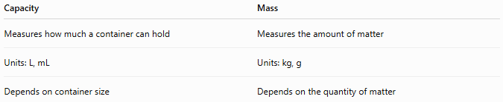
Capacity | Mass
Measures how much a container can hold | Measures the amount of matter
Units: L, mL | Units: kg, g
Depends on container size | Depends on the quantity of matter

Capacity vs. Volume of a Container
# Source: AI Source: Provided by: [Data Path: Persons Table -> ID Column: 1, Name_En Column: Motasem Essam] -> From: [ChatGPT] on [7/17/2026]
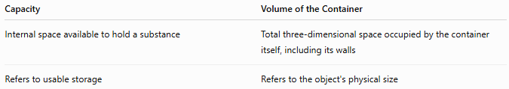
Capacity | Volume of the Container
Internal space available to hold a substance | Total three-dimensional space occupied by the container itself, including its walls
Refers to usable storage | Refers to the object's physical size

Conclusion
# Source: AI Source: Provided by: [Data Path: Persons Table -> ID Column: 1, Name_En Column: Motasem Essam] -> From: [ChatGPT] on [7/17/2026]
Capacity is the measurement of the maximum amount of a substance that a container can hold, most commonly liquids or gases. Although closely related to volume, capacity focuses on the storage capability of containers rather than the space occupied by an object. The liter (L) is the most widely used unit of capacity, with the cubic meter (m³) serving as the corresponding SI-derived unit. Accurate capacity measurement, using calibrated volumetric equipment and proper reading techniques, is essential in cooking, medicine, chemistry, manufacturing, commerce, and many everyday applications.

